PLSQL
Exercise 4: Functions
Scenario 1:
CREATE OR REPLACE FUNCTION CalculateAge(
p_dob DATE
)
RETURN NUMBER
IS
v_age NUMBER;
BEGIN
v_age := FLOOR(
MONTHS_BETWEEN(
SYSDATE,
p_dob
) / 12
);
RETURN v_age;
END;

/
Step 2: Test Function
SELECT CalculateAge(
TO_DATE('1985-05-15','YYYY-MM-DD')
) AS Age
FROM Dual;

Output

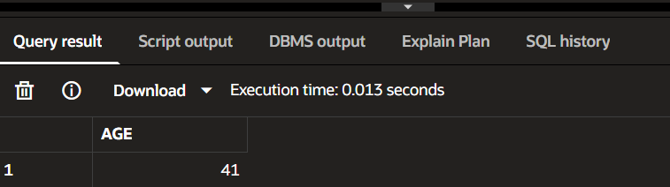
Use with Customers Table
SELECT CustomerID,
Name,
CalculateAge(DOB) AS Age
FROM Customers;

Sample Output
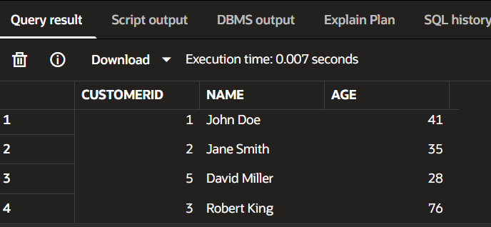
Scenario 2:

CREATE OR REPLACE FUNCTION CalculateMonthlyInstallment(
p_loan_amount NUMBER,
p_interest_rate NUMBER,
p_years NUMBER
)
RETURN NUMBER
IS
v_monthly_installment NUMBER;
BEGIN
v_monthly_installment :=
(p_loan_amount +
(p_loan_amount * p_interest_rate * p_years / 100))
/ (p_years * 12);
RETURN ROUND(v_monthly_installment,2);
END;
/
Test Function
SELECT CalculateMonthlyInstallment(
100000,
10,
5
) AS EMI
FROM Dual;

Output
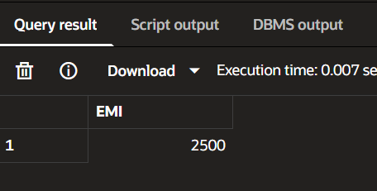
Scenario 3:

CREATE OR REPLACE FUNCTION HasSufficientBalance(

p_account_id NUMBER,

p_amount NUMBER

)

RETURN VARCHAR2

IS

v_balance NUMBER;

BEGIN

SELECT Balance

INTO v_balance

FROM Accounts

WHERE AccountID = p_account_id;

IF v_balance >= p_amount THEN

RETURN 'TRUE';

ELSE

RETURN 'FALSE';

END IF;

EXCEPTION

WHEN NO_DATA_FOUND THEN

RETURN 'ACCOUNT NOT FOUND';

END;

Test Function
SELECT HasSufficientBalance(
1,
500
) AS Result
FROM Dual;

Output

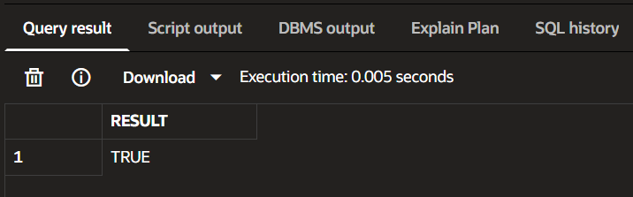
Test Insufficient Balance
SELECT HasSufficientBalance(
1,
5000
) AS Result
FROM Dual;

Output

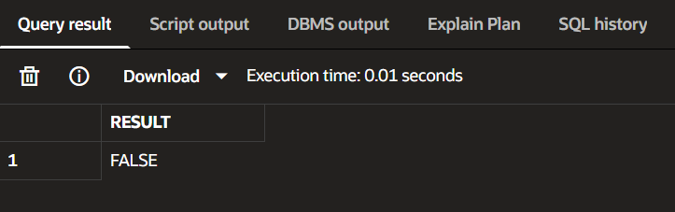

Test Invalid Account
SELECT HasSufficientBalance(
100,
500
) AS Result
FROM Dual;

Output

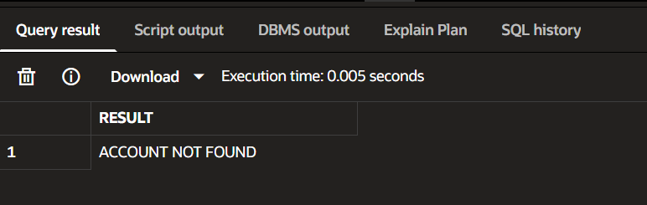
==================================================================
Exercise 5: Triggers

Scenario 1: CREATE OR REPLACE TRIGGER UpdateCustomerLastModified

BEFORE UPDATE

ON Customers

FOR EACH ROW

BEGIN

:NEW.LastModified := SYSDATE;

END;

/
Check Current Data
SELECT CustomerID,
Name,
LastModified
FROM Customers;

Update a Customer
UPDATE Customers
SET Balance = 5000
WHERE CustomerID = 1;
COMMIT;

Step 4: Verify
SELECT CustomerID,
Name,
Balance,
LastModified
FROM Customers
WHERE CustomerID = 1;
Output:

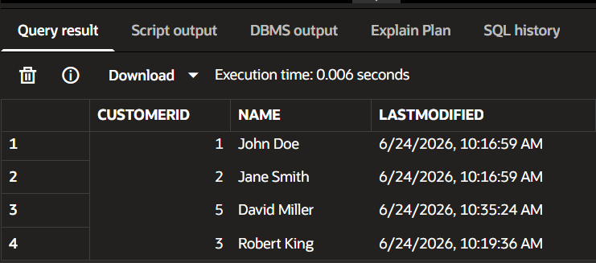
Scenario 2:

Create AuditLog Table
CREATE TABLE AuditLog (
LogID NUMBER GENERATED BY DEFAULT AS IDENTITY,
TransactionID NUMBER,
ActionDate DATE,
ActionType VARCHAR2(50)
);

Create Trigger
CREATE OR REPLACE TRIGGER LogTransaction
AFTER INSERT
ON Transactions
FOR EACH ROW
BEGIN
INSERT INTO AuditLog(
TransactionID,
ActionDate,
ActionType
)
VALUES(
:NEW.TransactionID,
SYSDATE,
'INSERT'
);
END;
/

Insert a Transaction

INSERT INTO Transactions
VALUES(
10,
1,
SYSDATE,
500,
'Deposit'
);
COMMIT;
Verify
SELECT *
FROM AuditLog;

Output

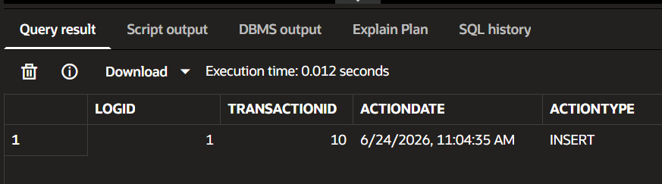
Scenario 3:

Create Trigger
CREATE OR REPLACE TRIGGER CheckTransactionRules
BEFORE INSERT
ON Transactions
FOR EACH ROW
DECLARE
v_balance NUMBER;
BEGIN
SELECT Balance
INTO v_balance
FROM Accounts
WHERE AccountID = :NEW.AccountID;
IF :NEW.TransactionType = 'Withdrawal' THEN
IF :NEW.Amount > v_balance THEN
RAISE_APPLICATION_ERROR(
-20001,
'Withdrawal exceeds account balance'
);
END IF;
ELSIF :NEW.TransactionType = 'Deposit' THEN
IF :NEW.Amount <= 0 THEN
RAISE_APPLICATION_ERROR(
-20002,
'Deposit amount must be positive'
);
END IF;
END IF;
END;
/

Test Valid Deposit

INSERT INTO Transactions
VALUES(
11,
1,
SYSDATE,
100,
'Deposit'
);
COMMIT;
Step 3: Test Invalid Deposit
INSERT INTO Transactions
VALUES(
12,
1,
SYSDATE,
-100,
'Deposit'
);

Output
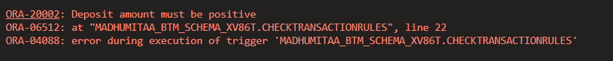
Test Invalid Withdrawal
Suppose Account 1 balance is 1000.
INSERT INTO Transactions
VALUES(
13,1,
SYSDATE,
5000,
'Withdrawal'
);

Output

===================================================================
Exercise 6: Cursors

Scenario 1:
DECLARE

CURSOR GenerateMonthlyStatements IS

SELECT c.CustomerID,

c.Name,

t.TransactionID,

t.TransactionDate,

t.Amount,

t.TransactionType

FROM Customers c

JOIN Accounts a

ON c.CustomerID = a.CustomerID

JOIN Transactions t

ON a.AccountID = t.AccountID

WHERE EXTRACT(MONTH FROM t.TransactionDate)

= EXTRACT(MONTH FROM SYSDATE)

AND EXTRACT(YEAR FROM t.TransactionDate)

= EXTRACT(YEAR FROM SYSDATE);

v_rec GenerateMonthlyStatements%ROWTYPE;

BEGIN

OPEN GenerateMonthlyStatements;

LOOP

FETCH GenerateMonthlyStatements

INTO v_rec;

EXIT WHEN GenerateMonthlyStatements%NOTFOUND;

DBMS_OUTPUT.PUT_LINE(

'Customer: ' || v_rec.Name ||

' | Transaction ID: ' || v_rec.TransactionID ||

' | Amount: ' || v_rec.Amount ||

' | Type: ' || v_rec.TransactionType

);

END LOOP;

CLOSE GenerateMonthlyStatements;

END;

/

Output:

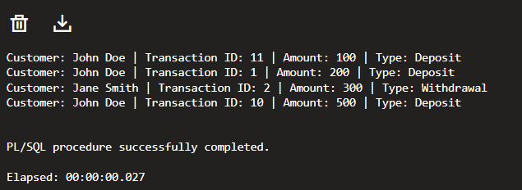
Scenario 2:
DECLARE

CURSOR ApplyAnnualFee IS

SELECT AccountID,

Balance

FROM Accounts;

v_accountid Accounts.AccountID%TYPE;

v_balance Accounts.Balance%TYPE;

BEGIN

OPEN ApplyAnnualFee;

LOOP

FETCH ApplyAnnualFee

INTO v_accountid,

v_balance;

EXIT WHEN ApplyAnnualFee%NOTFOUND;

UPDATE Accounts

SET Balance = Balance - 100

WHERE AccountID = v_accountid;

DBMS_OUTPUT.PUT_LINE(

'Annual Fee Applied to Account '

|| v_accountid

);

END LOOP;

CLOSE ApplyAnnualFee;

COMMIT;

END;

/
SELECT AccountID,

Balance

FROM Accounts;

Output:

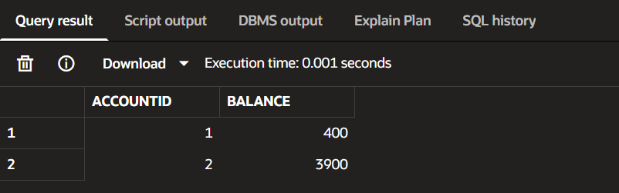
Scenario 3: UpdateLoanInterestRates
DECLARE

CURSOR UpdateLoanInterestRates IS

SELECT LoanID,

InterestRate

FROM Loans;

v_loanid Loans.LoanID%TYPE;

v_rate Loans.InterestRate%TYPE;

BEGIN

OPEN UpdateLoanInterestRates;

LOOP

FETCH UpdateLoanInterestRates

INTO v_loanid,

v_rate;

EXIT WHEN UpdateLoanInterestRates%NOTFOUND;

UPDATE Loans

SET InterestRate = InterestRate - 0.5

WHERE LoanID = v_loanid;

DBMS_OUTPUT.PUT_LINE(

'Interest Rate Updated for Loan '

|| v_loanid

);

END LOOP;

CLOSE UpdateLoanInterestRates;

COMMIT;

END;
SELECT LoanID,

InterestRate

FROM Loans; /

Output: 